Papertrail demo
Login to Papertrail and navigate to below url:
https://papertrailapp.com/systems/new
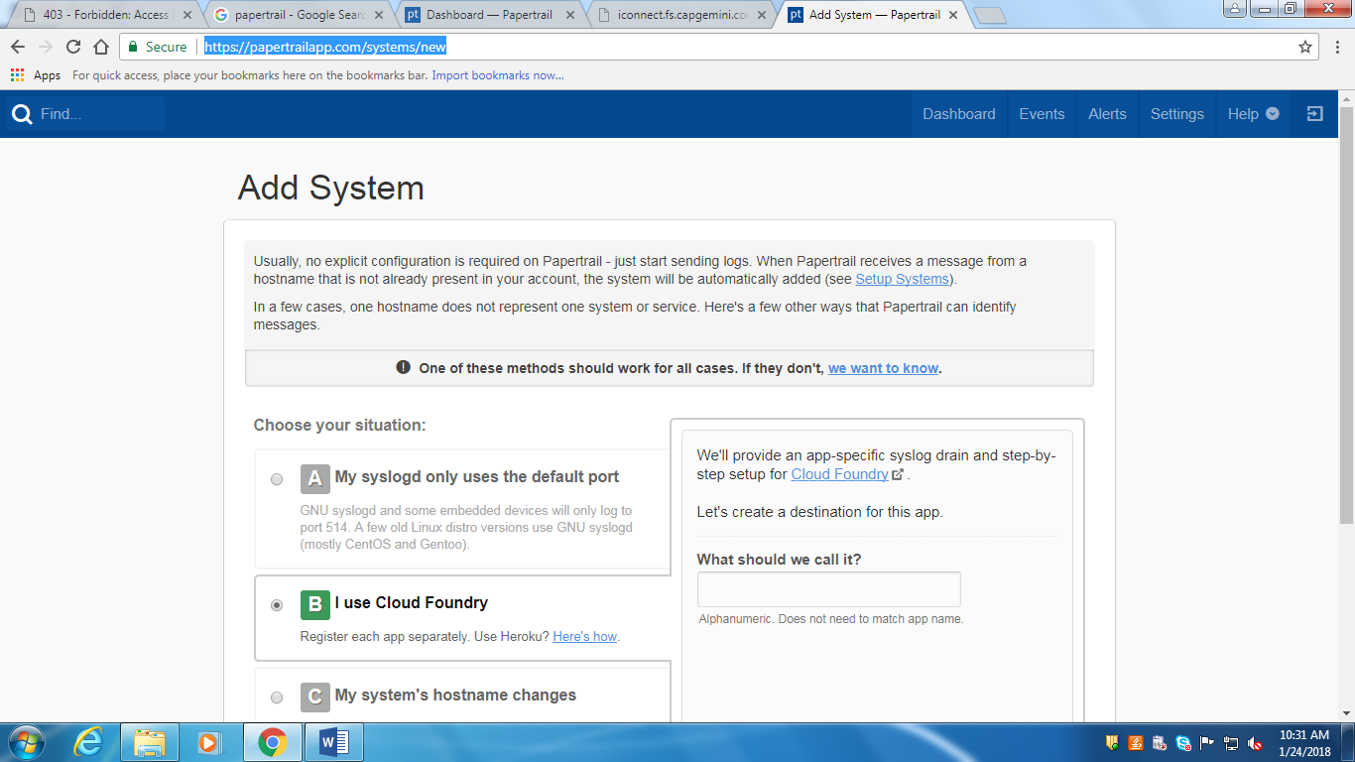
Choose I use cloud foundry: give some name and save the url provided by papertrial.
logs.papertrailapp.com:11839

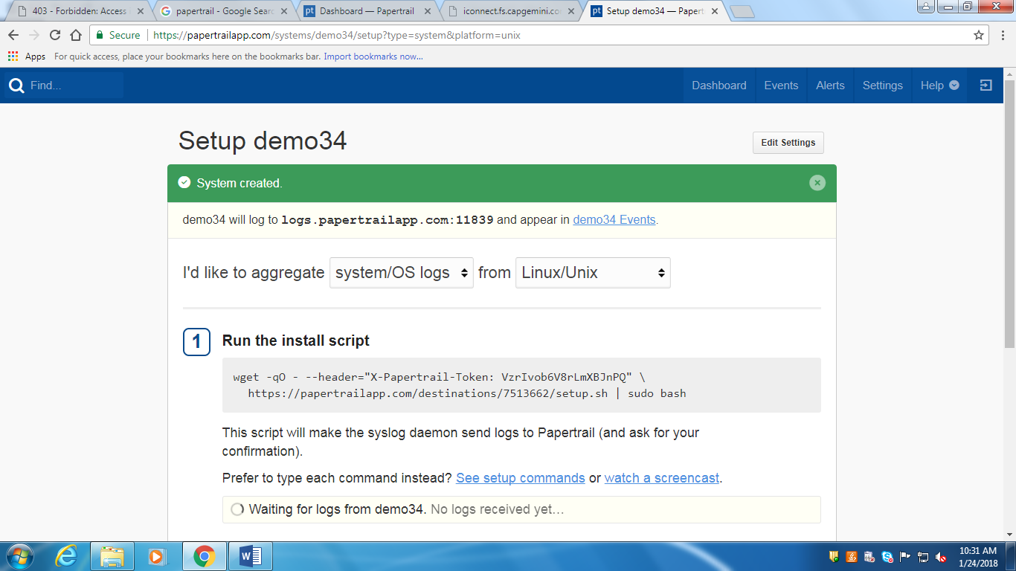

Login to PCF using cli and add service to application:
cf login -a api.run.pivotal.io

cf cups service_name –l syslog://<url-papertrail>

We need to bind the service to app in pivotal or through cli:
Cf bind-service app_name service_name

Cf restart app_name

cf push your_app
cf push appname -p path(target/xyz.jar)
For yml files directly we can use below command
cf push

